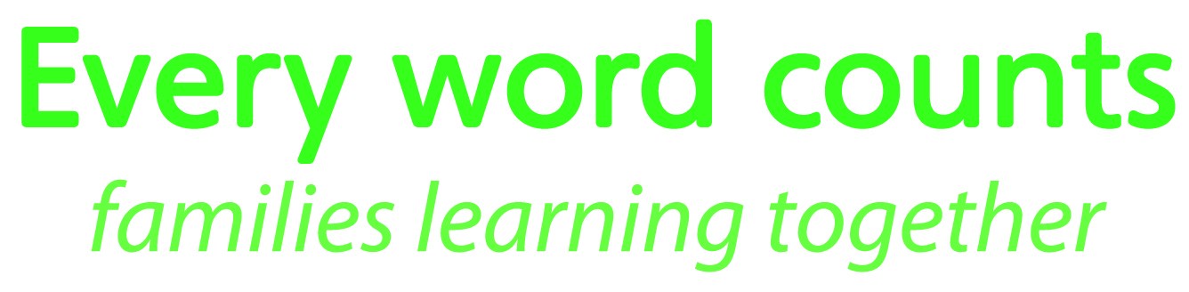

EVERY WORD COUNTS is based on the latest research into language, early literacy and maths learning for babies and young children.  The training programme and resources are designed to:

•       be integrated into existing home visiting and parenting programmes;

•       be used with parents and caregivers in homes or in group parenting sessions;

* equip home visitors, community workers, health visitors and play group facilitators with the knowledge and skills to support parents and caregivers in their efforts to build a strong language and learning foundation in babies and young children;
* be used by ECD practitioners wanting to improve their own knowledge and skills for their work with children;
* be used by families wanting to share new ideas and activities with those caring for their children.

**The programme aims to:**

* introduce parents to new ideas, linking these to their own situations and experience, and exploring ways to put these ideas into practice with their children
* help parents to understand what is meant by early literacy and maths and demonstrate how language, literacy and maths activities can be integrated into daily routines
* emphasise the importance of loving, responsive parenting and show the importance of talking with babies, toddlers and young children
* give concrete examples of different kinds of play and demonstrate the importance of play for developing language, literacy and maths
* encourage routines around activities such as storytelling and booksharing
* focus on ‘how to’, as well as ‘why’ early learning activities are important
* give many practical examples of how to support language, literacy and maths in informal ways that are appropriate for babies and young children

**EVERY WORD COUNTS - resources**

**Resources to share with parents and caregivers during home-visits and parenting groups:**

* + Six A5 books cover the following topics:
  + Talk, play and sing (birth to 2 years);
  + Talk and sing (3 to 5 years);
  + Play (3 to 5 years);
  + Share books (birth to 5 years);
  + Draw and write (3 to 5 years);
  + Enjoy maths everyday (3 to 5 years).

Some books do not require any resources to put the ideas into practice, while other books give instructions on how to make resources at home;

Pictures and key messages from the books are summarised in ‘leave behind’ sheets which serve as reminders toA3 parents.

**Resources for training home-visitors/community workers/ health visitors/ playgroup facilitators:**

* Guide for Trainers;
* Power point presentations with pictures from the books and short video clips showing good practice;
* A3 flip charts (designed to be used in workshops where no electricity and/or computer facilities are available);
* Workbook for practitioners;
* At home reminder sheets for parents.

The resources are currently available in English, isiXhosa and Afrikaans and will be available in isiZulu in 2016. Organisations can select any package of materials depending on their programme objectives and target groups.

**EVERY WORD COUNTS - training**

* Wordworks offers training to NGO programme managers, programme coordinators and trainers, who in turn train their organisation’s home visitors/community workers/health visitors and/or play group facilitators.
* At each training-of-trainers workshop, Wordworks trainers share information, ideas, activities and materials and build skills and confidence through a participative approach to learning.
* Training programmes are tailored to match the package of materials chosen by an organisation. Wordworks will offer assistance to partners to integrate EVERY WORD COUNTS resources into their existing programme delivery.
* Wordworks is exploring short course certification for trainers who complete the course and submit a portfolio.

**EVERY WORD COUNTS - partnerships with Wordworks**

* Thanks to donor funding for 2015[1], Wordworks is able to partner with organisations and offer training and some resources for home-visitors at no cost.
* Partner organisations will need to cover the cost of travel and accommodation for their staff who attend the training.
* Partner organisations will be required to contribute information, reflections and insights in exchange for training from Wordworks.
* Wordworks will offer assistance to partners to integrate EVERY WORD COUNTS monitoring tools into their existing monitoring systems.
* Partner organisations will be required to sign a Memorandum of Agreement with Wordworks. The following is covered in the MOA:
  + Training commitments
  + Mentoring and on-going support by Wordworks
  + Setting up monitoring systems in the partner organisation
  + Commitment by the partner organisation to implement the programme and supply additional resources, and to report on project progress and outcomes
  + Time frames for the above

**Why are the EVERY WORD COUNTS resources needed?**

The majority of children in South Africa are not able to access quality centre-based early learning programmes, and there is growing recognition of the need to strengthen early learning through families. To address this need, a number of organisations deliver services to vulnerable children by training and resourcing home visitors and play group facilitators to work with parents and caregivers. Existing home visitor/parenting programmes cover topics such as nutrition, health and safety, access to grants, child development and early learning. The EVERY WORD COUNTS resources specifically focus on supporting parents to build language, early literacy and maths.

**About Wordworks**

Wordworks supports early language and literacy learning among children from historically disadvantaged communities in South Africa. We seek to share our materials, know-how and enthusiasm with teachers, parents, volunteer tutors and home visitors in a respectful and inclusive way. At Wordworks, we are passionate about children and passionate about literacy. We believe that every child in South Africa deserves the chance to learn to read and write successfully. And we know that without that chance, many children will never reach their full potential.

For more information, visit [www.wordworks.org.za](http://www.wordworks.org.za)

1. We gratefully acknowledge funding and support from the DG Murray Trust and The Claude Leon Foundation in developing the EVERY WORD COUNTS resources and training programme. The Claude Leon Foundation is funding our work with partners in 2015.