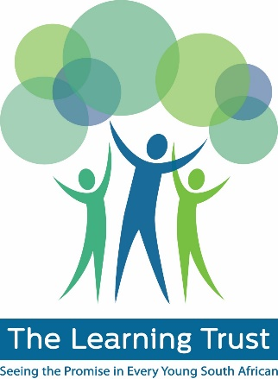 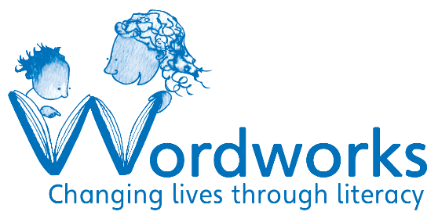

**Are you an organisation working with young children aged 5-8 years? Is one of your aims that more children are supported in learning to read and write successfully?**

**Do you want to join a community of organisations working together to deliver collective impact? Would you like to receive training, support and funding to achieve this impact?**

The Learning Trust (TLT) and Wordworks are working in partnership to support organisations that offer high quality tutoring programmes for young children learning to read and write.

We are growing a network of tutoring programmes, where members are provided with knowledge, skills and resource-sharing opportunities. This project aims to increase the number of high impact, sustainable early literacy tutoring programmes in South Africa.

**You can apply to receive a grant for a full year of intensive training and support from The Learning Trust and Wordworks.** This programmatic training and support, programme funding and development of organisational capacity (e.g. fundraising and governance, strategy and M&E and financial controls) will enable organisations to implement the full Wordworks model and increase their impact. The grant will include tracking and monitoring of collective impact.

The deadline for applications is **5pm on Friday the 12th of February 2016.** To apply please see the attached application form and return it to shelley@wordworks.org.za.

**Criteria and eligibility/Minimum standards for quality implementation**

**The following criteria need to be met by any organisation wanting to receive intensive training, support and programme funding:**

|  |  |
| --- | --- |
| ☐ | An emerging community based organisation or a more established organisation looking to improve or change its tutoring model* |
| ☐ | Based in the Western Cape |
| ☐ | A registered non-profit organisation or intention of registering. |
| ☐ | A track-record of delivering a quality service/programme for at least one year. |
| ☐ | A suitable and secure venue for tutors to work with young children |
| ☐ | At least 1 part-time salaried person or a committed founder/co-founder who has ideally been involved tutoring and is committed to making the programme work. This person will need to recruit, train and mentor tutors and manage administration and recordkeeping. |
| ☐ | An assistant (can be a volunteer) and either a committed team of tutors OR access to tutors that are able to attend training and work with children for at least six months. |
| ☐ | Links with a school/ECD Centre whose management team and principal are supportive of a tutoring programme. |
| ☐ | Willingness to follow the lesson structure in the guidelines for tutors and apply Wordworks’ principles of one tutor working with two children in a supportive learning environment. |
| ☐ | Commitment to explaining organisational/school policies and procedures around child protection to tutors and ensuring these are adhered to. |
| ☐ | Willingness to use Wordworks’ assessment tool and a specified database or template for collection of attendance records, test scores and other data to inform collective impact. |
| ☐ | A collaborative mind-set and dedication to capacity building and community development. |
| ☐ | Close alignment with The Learning Trust's values of humility, diversity, honesty and a commitment to learning. |

*organisations that have previously attended Wordworks training are still eligible to apply.

In addition to the above, if your organisation is going to be working with children at a local school, you must identify a staff member to champion the programme, teachers must be informed about and supportive of the programme and there must be buy-in from the principal and school management team.

**Application Process**

Deadline for applications is Friday the 12th of February 2016. Applications will be reviewed and you will be contacted for a follow-up telephonic interview in the week of the 22nd of February 2015. Successful applicants will be informed of next steps, which may include a site visit and a meeting with key programme, managerial staff and board members. The preliminary dates for these visits is the last week in February.

The three day training will take place in mid-April 2016 and two members of staff who will co-ordinate the programme must be available for the full training. Dates will be confirmed with organisations in March.

If you do not meet the requirements outlined here but are interested in working towards them or you would like to discuss your application and specific needs please contact Shelley O’Carroll on 021 788 9233 or email shelley@wordworks.org.za.