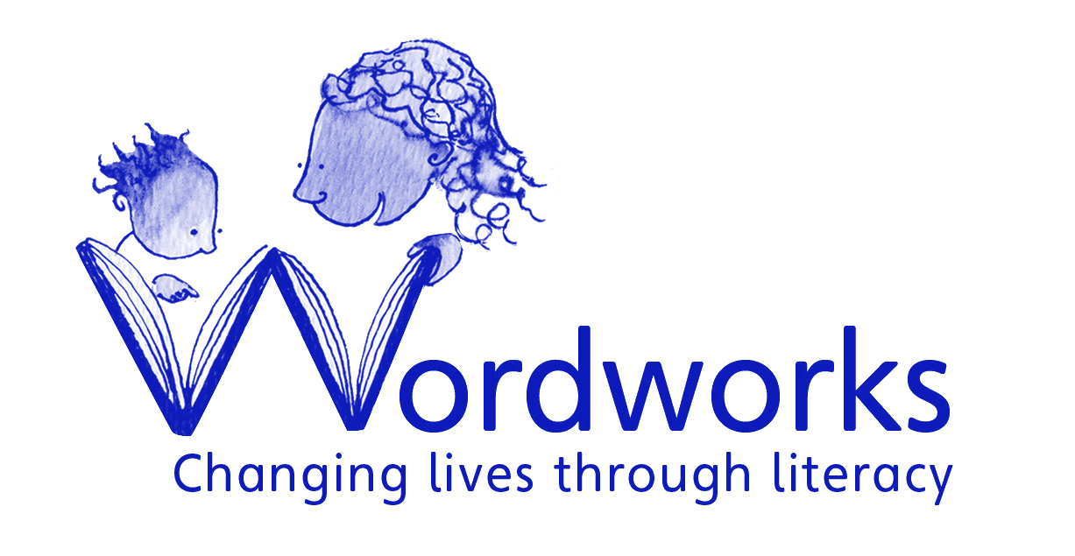

Mentors: Home-School Partnership Programme
Timetable and process for recruitment

- All applications must be received by 19th September 2016. Late applications will not be considered.

- Please send your application by email to recruitment@wordworks.org.za. Applications may also be posted to Applications, Wordworks, 2 Jacobs Ladder, St James, 7945.

- Shortlisted candidates will be invited to an interview. Interviews will take place on the 27th and 28th of September 2016. Interviews could be conducted on skype for those applying from outside of the Cape Town area.

- All applications must consist of:
- a completed personal details form
- an up-to-date Curriculum Vitae
- a letter of motivation
- the names and contact details of two referees

- Your letter of motivation should be no more than 2 sides of A4 paper and should set out clearly how you meet each criteria in the person specification. Please be as specific as possible, providing examples and evidence where relevant, as this will be the main method that we use to assess your suitability for the position.

- Your referees should be your current or former employers or managers. One referee must be from your current employer if you are working at the moment. We will not contact your referees prior to the interview.

- Please check your application carefully before sending it to us. If you do not include all the information in points 4-6 above, we will not be able to consider your application.

- Unfortunately, we are unable to respond to all applicants. If you are not contacted by Wordworks within thirty days after the above closing date, you should consider your application to have been unsuccessful.

