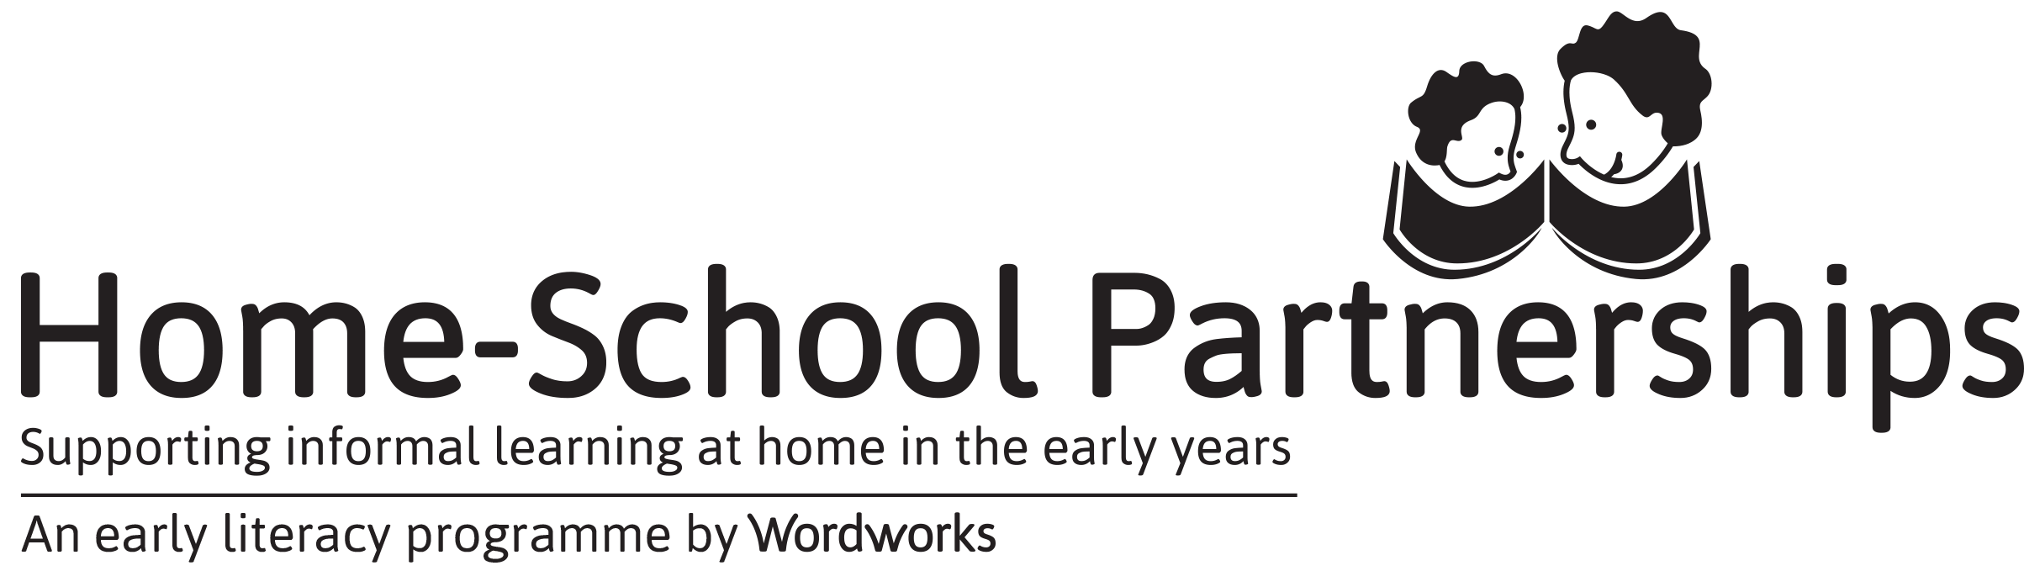

2019 FIRST REQUEST FOR PARENT RESOURCES: SESSIONS 1 – 4
Choose 1 of these 3 ways to complete your request for resources:
- Type into this form and email it to admin@wordworks.org.za
- Write on this form and fax it to 086 775 7930
- Complete this form online at https://goo.gl/forms/fcoVVDGddJ1VEZoH2

YOU MUST SUBMIT YOUR REQUEST FORM AT LEAST TWO WEEKS BEFORE THE START OF YOUR SESSIONS WITH PARENTS

Please complete ONLY ONE form per school

We have raised funds for materials for a maximum of 30 parents per school.
If you wish to involve more parents than this, the additional materials will be for your school’s account.
As a school running HSP, you will be eligible for a WordNetworks discount.
Contact orders@wordworks.org.za for an HSP order form.
We know that parent attendance is unpredictable, but ask that all sponsored, unused materials be returned to Wordworks.

NAME OF SCHOOL _________________________________________________
Dear Wordworks,
Please send us resources as follows:
PARENT TOTALS FOR  SESSIONS 1 – 4 RESOURCES | INSERT TOTALS
ENGLISH
AFRIKAANS
ISIXHOSA
TOTAL NUMBER OF PARENTS

Thank you! ☺
HSP Lead Facilitator: __________________________

Remember to distribute Workbooks at Session 1 and stationery packs at Session 3.

