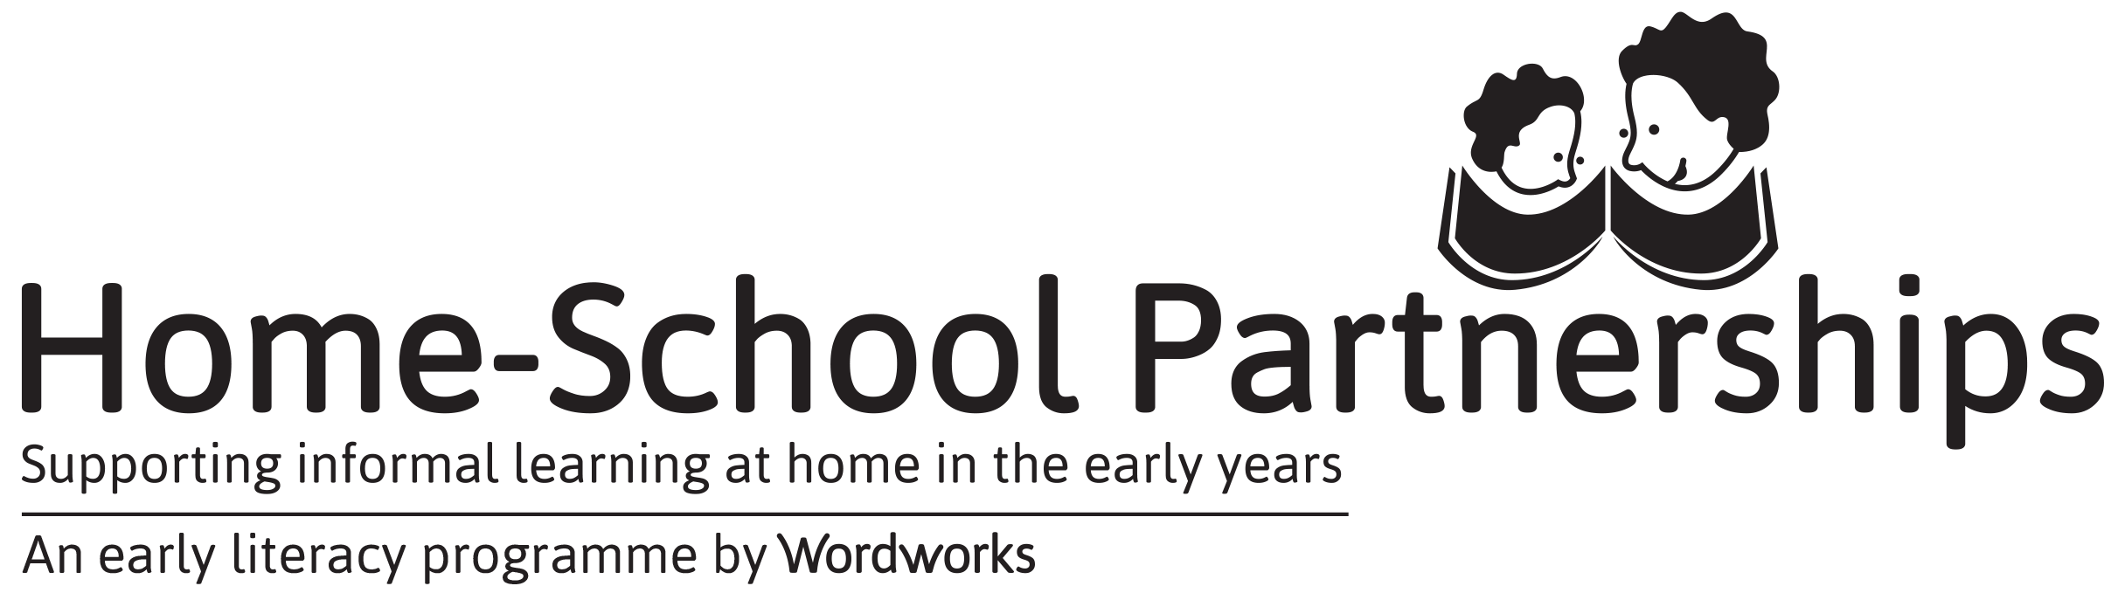

2019 SECOND REQUEST FOR PARENT RESOURCES: SESSIONS 5 – 8
Choose 1 of these 3 ways to complete your request for resources:
- Type into this form and email it to admin@wordworks.org.za
- Write on this form and fax it to 086 775 7930
- Complete this form online at https://goo.gl/forms/8ZmB07O8TRMshIBk1

YOU MUST SUBMIT YOUR REQUEST FORM STRAIGHT AFTER SESSION 3

Please complete ONLY ONE form per school
We have raised funds for materials for a maximum of 30 parents per school.
If you wish to involve more parents than this, the additional materials will be for your school’s account.
As a school running HSP, you will be eligible for a WordNetworks discount.
Contact orders@wordworks.org.za for an HSP order form.
We know that parent attendance is unpredictable, but ask that all sponsored, unused materials be returned to Wordworks.

NAME OF SCHOOL_________________________________________________
Dear Wordworks,
Please send us resources as follows:
PARENT TOTALS FOR  SESSIONS 5 – 8 RESOURCES | INSERT TOTALS
ENGLISH
AFRIKAANS
ISIXHOSA
TOTAL NUMBER OF PARENTS
We will return stationery packs and Workbooks that we have not needed due to a drop in parent numbers since our First Request for Resources.
Thank you! ☺
HSP Lead Facilitator: _______________________________
Remember to distribute ‘My Body and Space’ and ‘Supporting Informal Learning at Home’ Booklets at Sessions 5 & 6 and Literacy Game Packs at Session 7.

