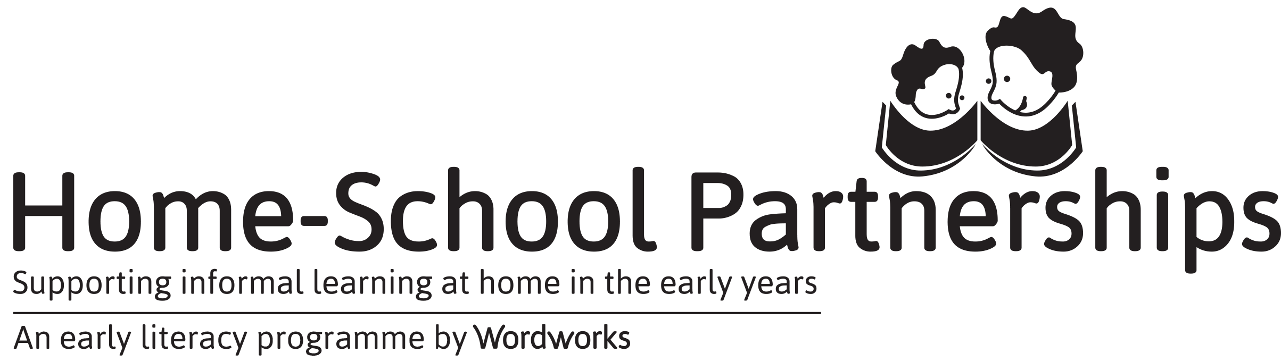
2019 Programme Report
There are 3 ways to complete this report:
- Type into this form and email it to data@wordworks.org.za
- Write on this form and fax it to 086 775 7930
- Complete this form online at https://goo.gl/forms/j9KcV6ZKduvcCbKo2

Please complete this report as soon as you can after your parents’ graduation.
Name of school:
Today’s date:
Date of first session |  |  | Date of graduation
Number of parents that received certificates
Number of women |  | Number of men |  | Total
Teacher-Facilitators this year
Name |  |  | Surname

We will return the following sponsored resources to Wordworks that we have not needed due to a drop in parent numbers since our Second Request for Resources:
Resource | Number of returns
My Body and Space booklets
Supporting Informal Learning at Home booklets
Literacy Game Packs
Please share three of your favourite parent quotes/ reflections
(You could look at the letters parents wrote after Session 3, the feedback they completed after Session 8 or you could share a special verbal comment!)

What were the main highlights and challenges of your programme this year?

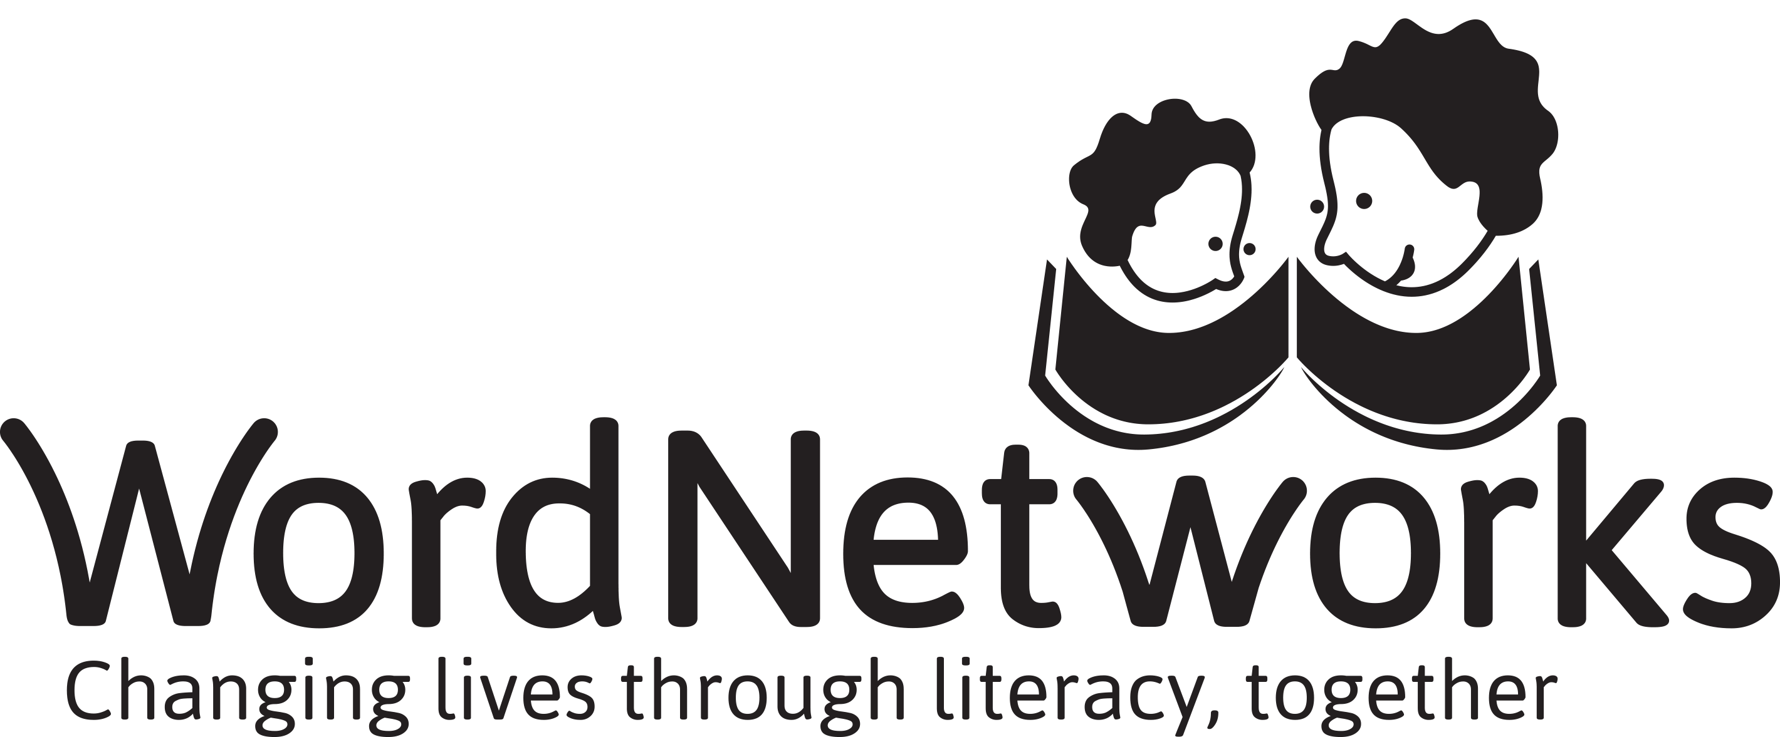
Don’t forget to send us some photos!
We’d love some photos of parents doing an activity and some of the parent graduation.
Please WhatsApp or email these to your Mentor.

