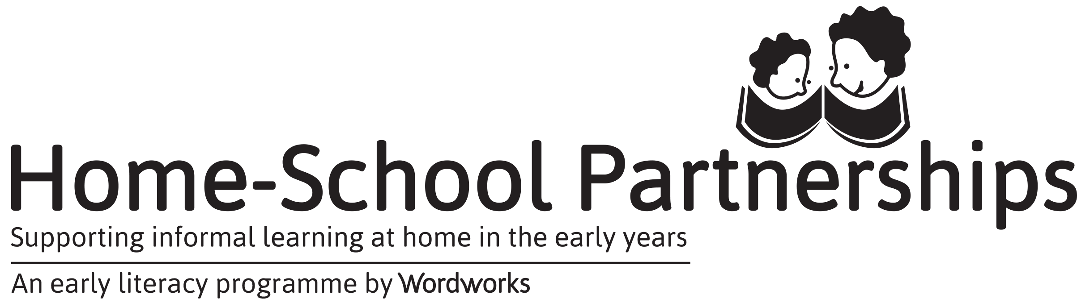

2019 Programme Report
Zintathu iindlela zokugcwalisa:
- Bhala kwelixwebhu uthumele nge email ku- data@wordworks.org.za
- Gcwalisa ixwebhu uthumele nge Fax- 086 775 7930
- Gcwalisa ngokucofa le link - https://goo.gl/forms/j9KcV6ZKduvcCbKo2

Nceda unike ingxelo ngokukhawuleza kangangoko unako emva kothweso lwabazali.
Igama lesikolo:
Umhla wanamhlanje:
Umhla weseshoni yokuqala |  |  | Umhla wothweso lwabazali
inani lwabazali abafumana iziqinisekiso zoqeqesho
inani lamabhinqa |  | inani lamadoda |  | Bebonke
Ootitshala abangabaqeqeshi kulonyaka
Igama |  |  | Ifani

Sizakuzibuyisa izixhobo ezingasetyenziswanga ebezinikelwe ngabakwa Wordworks ngenxa yokwehla kwenani labazali, ngoku isicelo sesibini sesi-
Izixhobo | Inani lezibuyiswayo
Umzimba wam nendawo ejikeleze umzimba wam
Ukuxhasa imfundo yasekhaya engamiselekanga
Iipakethe zemidlalo

Nceda wabelane ngezimvo ezintathu ozithandileyo zabazali.
(Ungajonga kwiileta ezazibhalwe ngabazali emva kweseshoni yesi 3, ingxelo emva kweseshoni yesi 8okanye ungacaphula kwintetho ekhethekileyo yomzali!

Zeziphi ezona mbalasane kunye nemingeni kwinkqubo yakho kulonyaka?

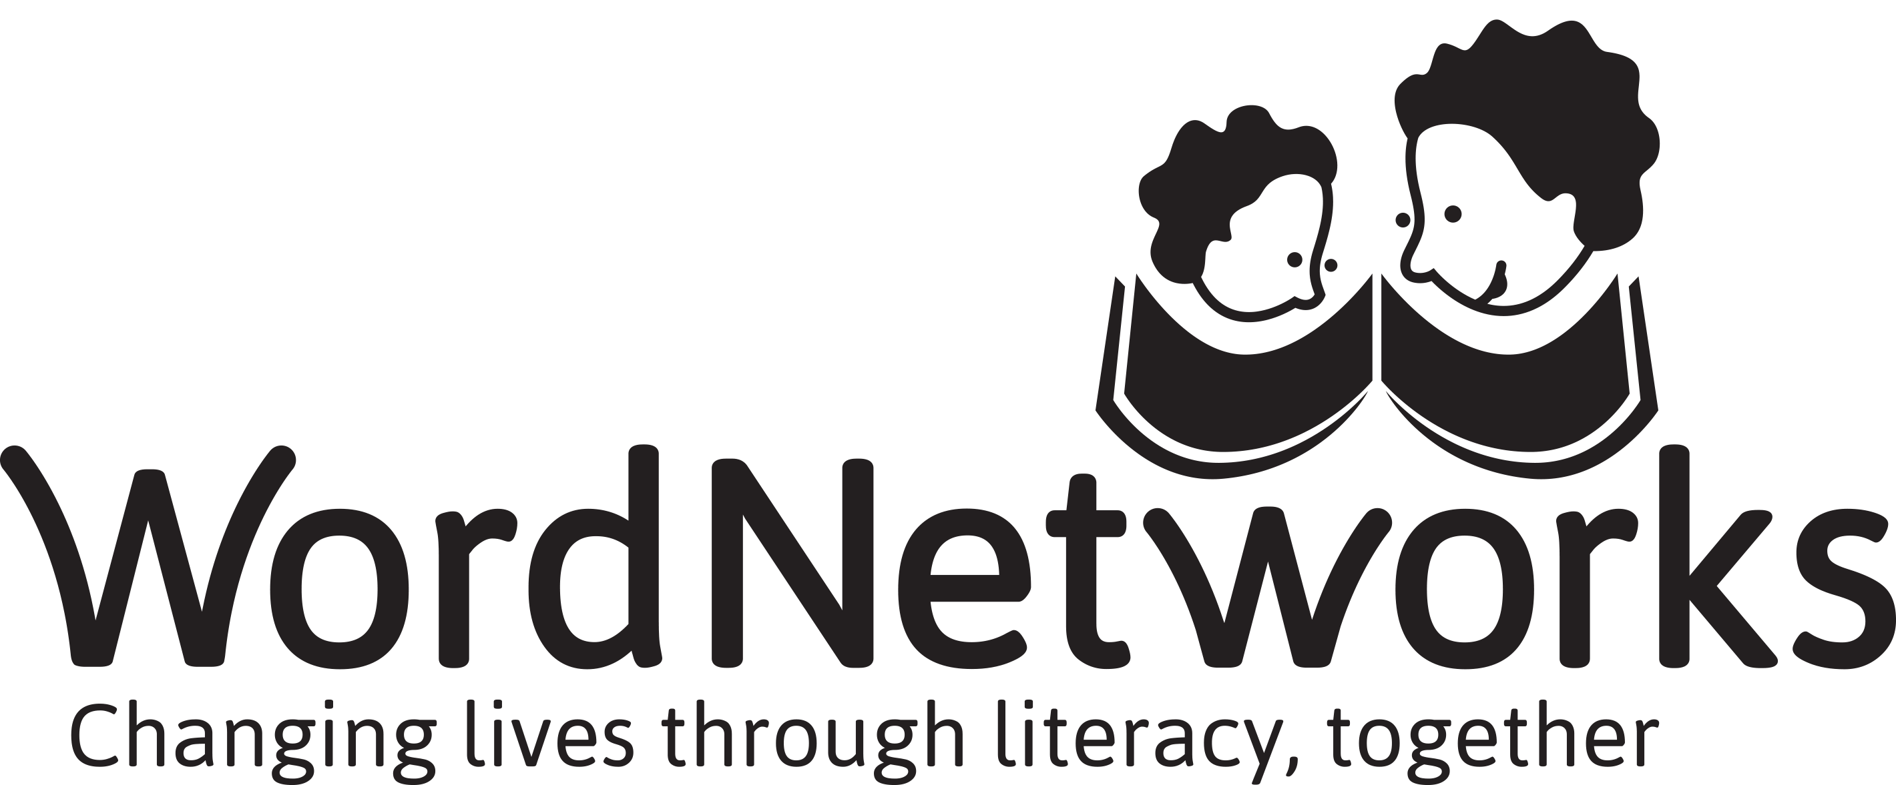
Ungalibali ukusithumelela inxalenye yamafoto!
Singathanda ukubona amafoto abazali besenza eminye yemisebenzi namanye amafoto abazali befumana iziqinisekiso zabo. Thumela nge WhatsApp okanye nge imeyile kwimento yakho.

