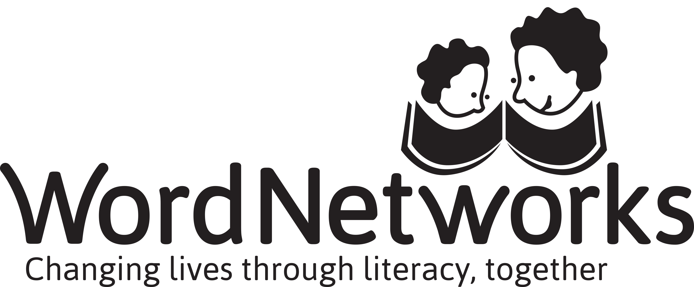

Code for Facilitators
Facilitators are at the heart of the Home-School Partnerships programme and the important work done to organise and facilitate parent courses is deeply appreciated.
As members of WordNetworks, all our work is value-based and we strive to demonstrate through our actions the values we stand for.
In particular, we
- Make every effort to be reliable, punctual, prepared and focussed when delivering the programme.
- Uphold the confidentiality of information shared on the programme unless explicit permission has been granted to share this.
- Are sensitive to, and accepting of the differences between people.
- Show consideration and kindness towards all those with whom we work.
- Are appreciative of the experience, knowledge and skills of other people and pay careful attention to their views, contribution and feedback.
- Offer empathy, support and encouragement to all we work with so that they may realise their full potential.
- Share what we have learned and created in a respectful and accessible way, seeking to collaborate and grow together.
I have read and understood the Facilitators’ Code and am committed to upholding it.

…………………………………………………………………………………………………….. (Name)

………………………………………………………………………………………………. (Signature)

…………………………………………………………………………………………………..… (Date)

