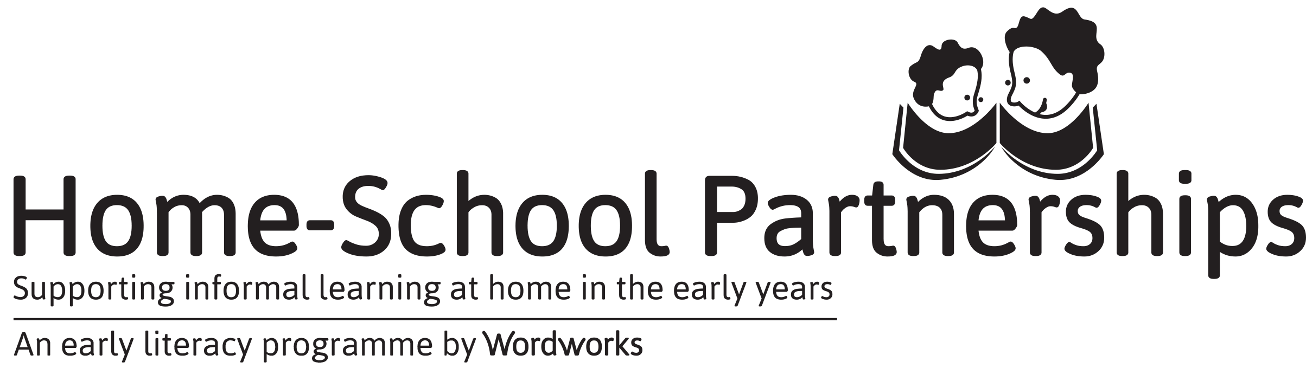

facilitator’s Self-evaluation
How are you doing?
This questionnaire will help you to see where you have made progress and where you may want to develop as a Facilitator.
How can you use the form?
- If you are currently training to be a Facilitator, you will be asked to complete this self-evaluation twice and to reflect on your learning as part of your portfolio.
- If you are an experienced Facilitator, it is not compulsory to complete the questionnaire (unless you are submitting a portfolio). We do, however, recommend that you spend time each year reflecting on your own growth and practice as a Facilitator. You may choose to do this privately as an individual. You might also decide that all members of your facilitation team will reflect together. You might decide to share your learning with your Wordworks Mentor.
However you decide to use this questionnaire, please be honest so you can truly track your own growth as a facilitator!
Level Description | What this means
- Not done | This still needs to be included/ You have neglected this issue/ You have not had time to do this.
- Needs more work | You are working on this area but could give it extra attention. You may need support in this area.
- Developing steadily | You have been really trying to do / include this and feel it is getting better all the time.
- Strong part of my facilitation | You feel this aspect is in line with your training by Wordworks. You could share this good practice with others.
Facilitator: School: DATE:
 | LEVEL DESCRIPTION (make an X in one box per row) |  |  |  | NOTES FOR NEXT TIME
Area of development | Not done | Needs more work | Developing steadily | Strong part of my facilitation | What I would like to change  (If anything)

My attitudes
I praise and encourage parents.
I listen carefully to parents’ questions and answers and respond appropriately and positively.
I treat everybody without prejudice and behave in an open and accepting way.
- My knowledge of the programme content
I have a good understanding of the material.
I can link parents’ feedback and examples to the material in the guide.
I understand the purpose of different activities and communicate the purpose to the parents.
I have read further and extended my knowledge.
- My facilitation
The venue is set up to encourage group work and communication between participants and facilitators.
I present the programme with enthusiasm and care.
I balance group work and “facilitator talk”.
I am able to be flexible with the programme, leaving room for questions or changes, but ensure I complete the content for each session.
If a parent’s answer is off track, I am able to make suggestions without making her or him feel bad.
I don’t allow one person to dominate by asking or answering too many questions. I encourage all parents to participate.
I don’t talk too much or tell too many stories from my life. I rather encourage parents to share their stories.

- Team preparation and administration
We ensure that we submit our request for materials to Wordworks well in advance of our parent sessions.
I am well prepared and organised for each session.
We ensure participants sign the register at each session.
We ensure that our 3-2-1 report is submitted to Wordworks soon after the end of our programme
We ensure we RSVP for Wordworks planning and refresher events on time.
We ensure we complete the re-committal for the next year’s programme and send it to Wordworks on time.
- Team communication
As a facilitation team, we communicate openly and constructively with one another and work together well.
We keep our mentor informed about our progress and work with her to improve our programme.
We have communicated with our principal/ management/ SGB and invited them to visit the course to acknowledge the commitment of parents and facilitators.
We have made District Officials aware of our programme and shared our successes and challenges with them.
We have invited community media and organisations and/ or local businesses to our graduation to encourage public conversation about and support for home-school partnerships and to honour our parents’ achievements.
