Kind and loving words to use with our children 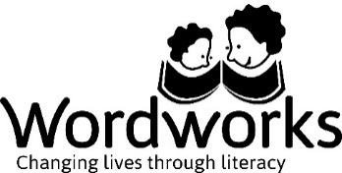

I like the way you did that...
You have really thought about your drawing … well done!
Good for you!
I like your idea...
Well done – keep on trying...
I can see you are doing your best...
Keep thinking, keep thinking...
I like to see that you are trying...
You so nearly did it!
I like your colours!
You are on the right track...
Your ideas are great...
A good try...
You’ve almost got it...
Good remembering!
Now that’s what I call a good job...
This is so much better...
Nothing can stop you now!
Keep it up...
You’re doing fine...
Keep trying, you’re doing so well...
Now you have figured it out!
One more time and you will have it...
Look at you... well done!

