Would you like to help young
children learn to read?

Would you like to help young
children learn to read?

Our school/organisation is going to be offering extra support for reading and writing to children in Grades R, 1 and 2. We will be using the Ready Steady Read Write tutoring programme developed by Wordworks. Join us for an information session to find out more.

Date: Time: Venue:

We would love you to join our team, to share in the joy of helping young children learn to read and write!

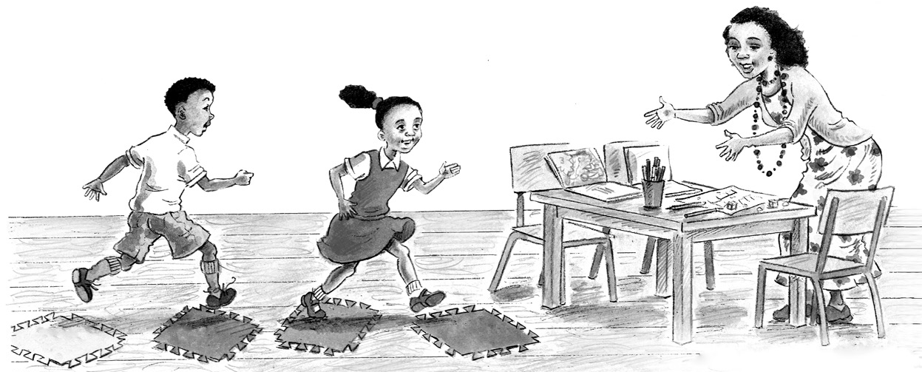

“It’s been one of the most wonderful things I have done in my life so far. Giving back is GREAT!” Desiree, tutor
Our school/organisation is going to be offering extra support for reading and writing to children in Grades R, 1 and 2. We will be using the Ready Steady Read Write tutoring programme developed by Wordworks. Join us for an information session to find out more.

Date: Time: Venue:

We would love you to join our team, to share in the joy of helping young children learn to read and write!

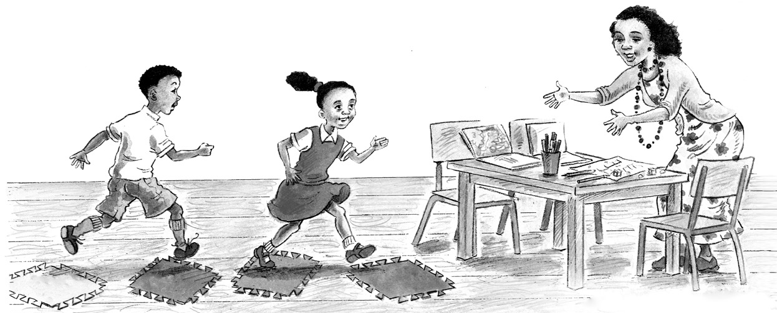

“It’s been one of the most wonderful things I have done in my life so far. Giving back is GREAT!” Desiree, tutor

www.wordworks.org.za
www.wordworks.org.za

