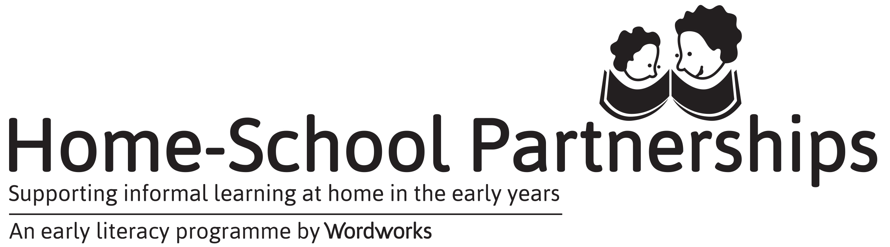

This is to certify that

completed the Parent Programme
to support young children’s learning at home

Topics included:
Parents/guardians as children’s first teachers
Emergent writing and the importance of drawing
The importance of telling and reading stories
Making your own books
Listening games to help with reading and writing
Basic concepts for reading and maths development
Games to play for the development of big and small muscles
Positive parenting

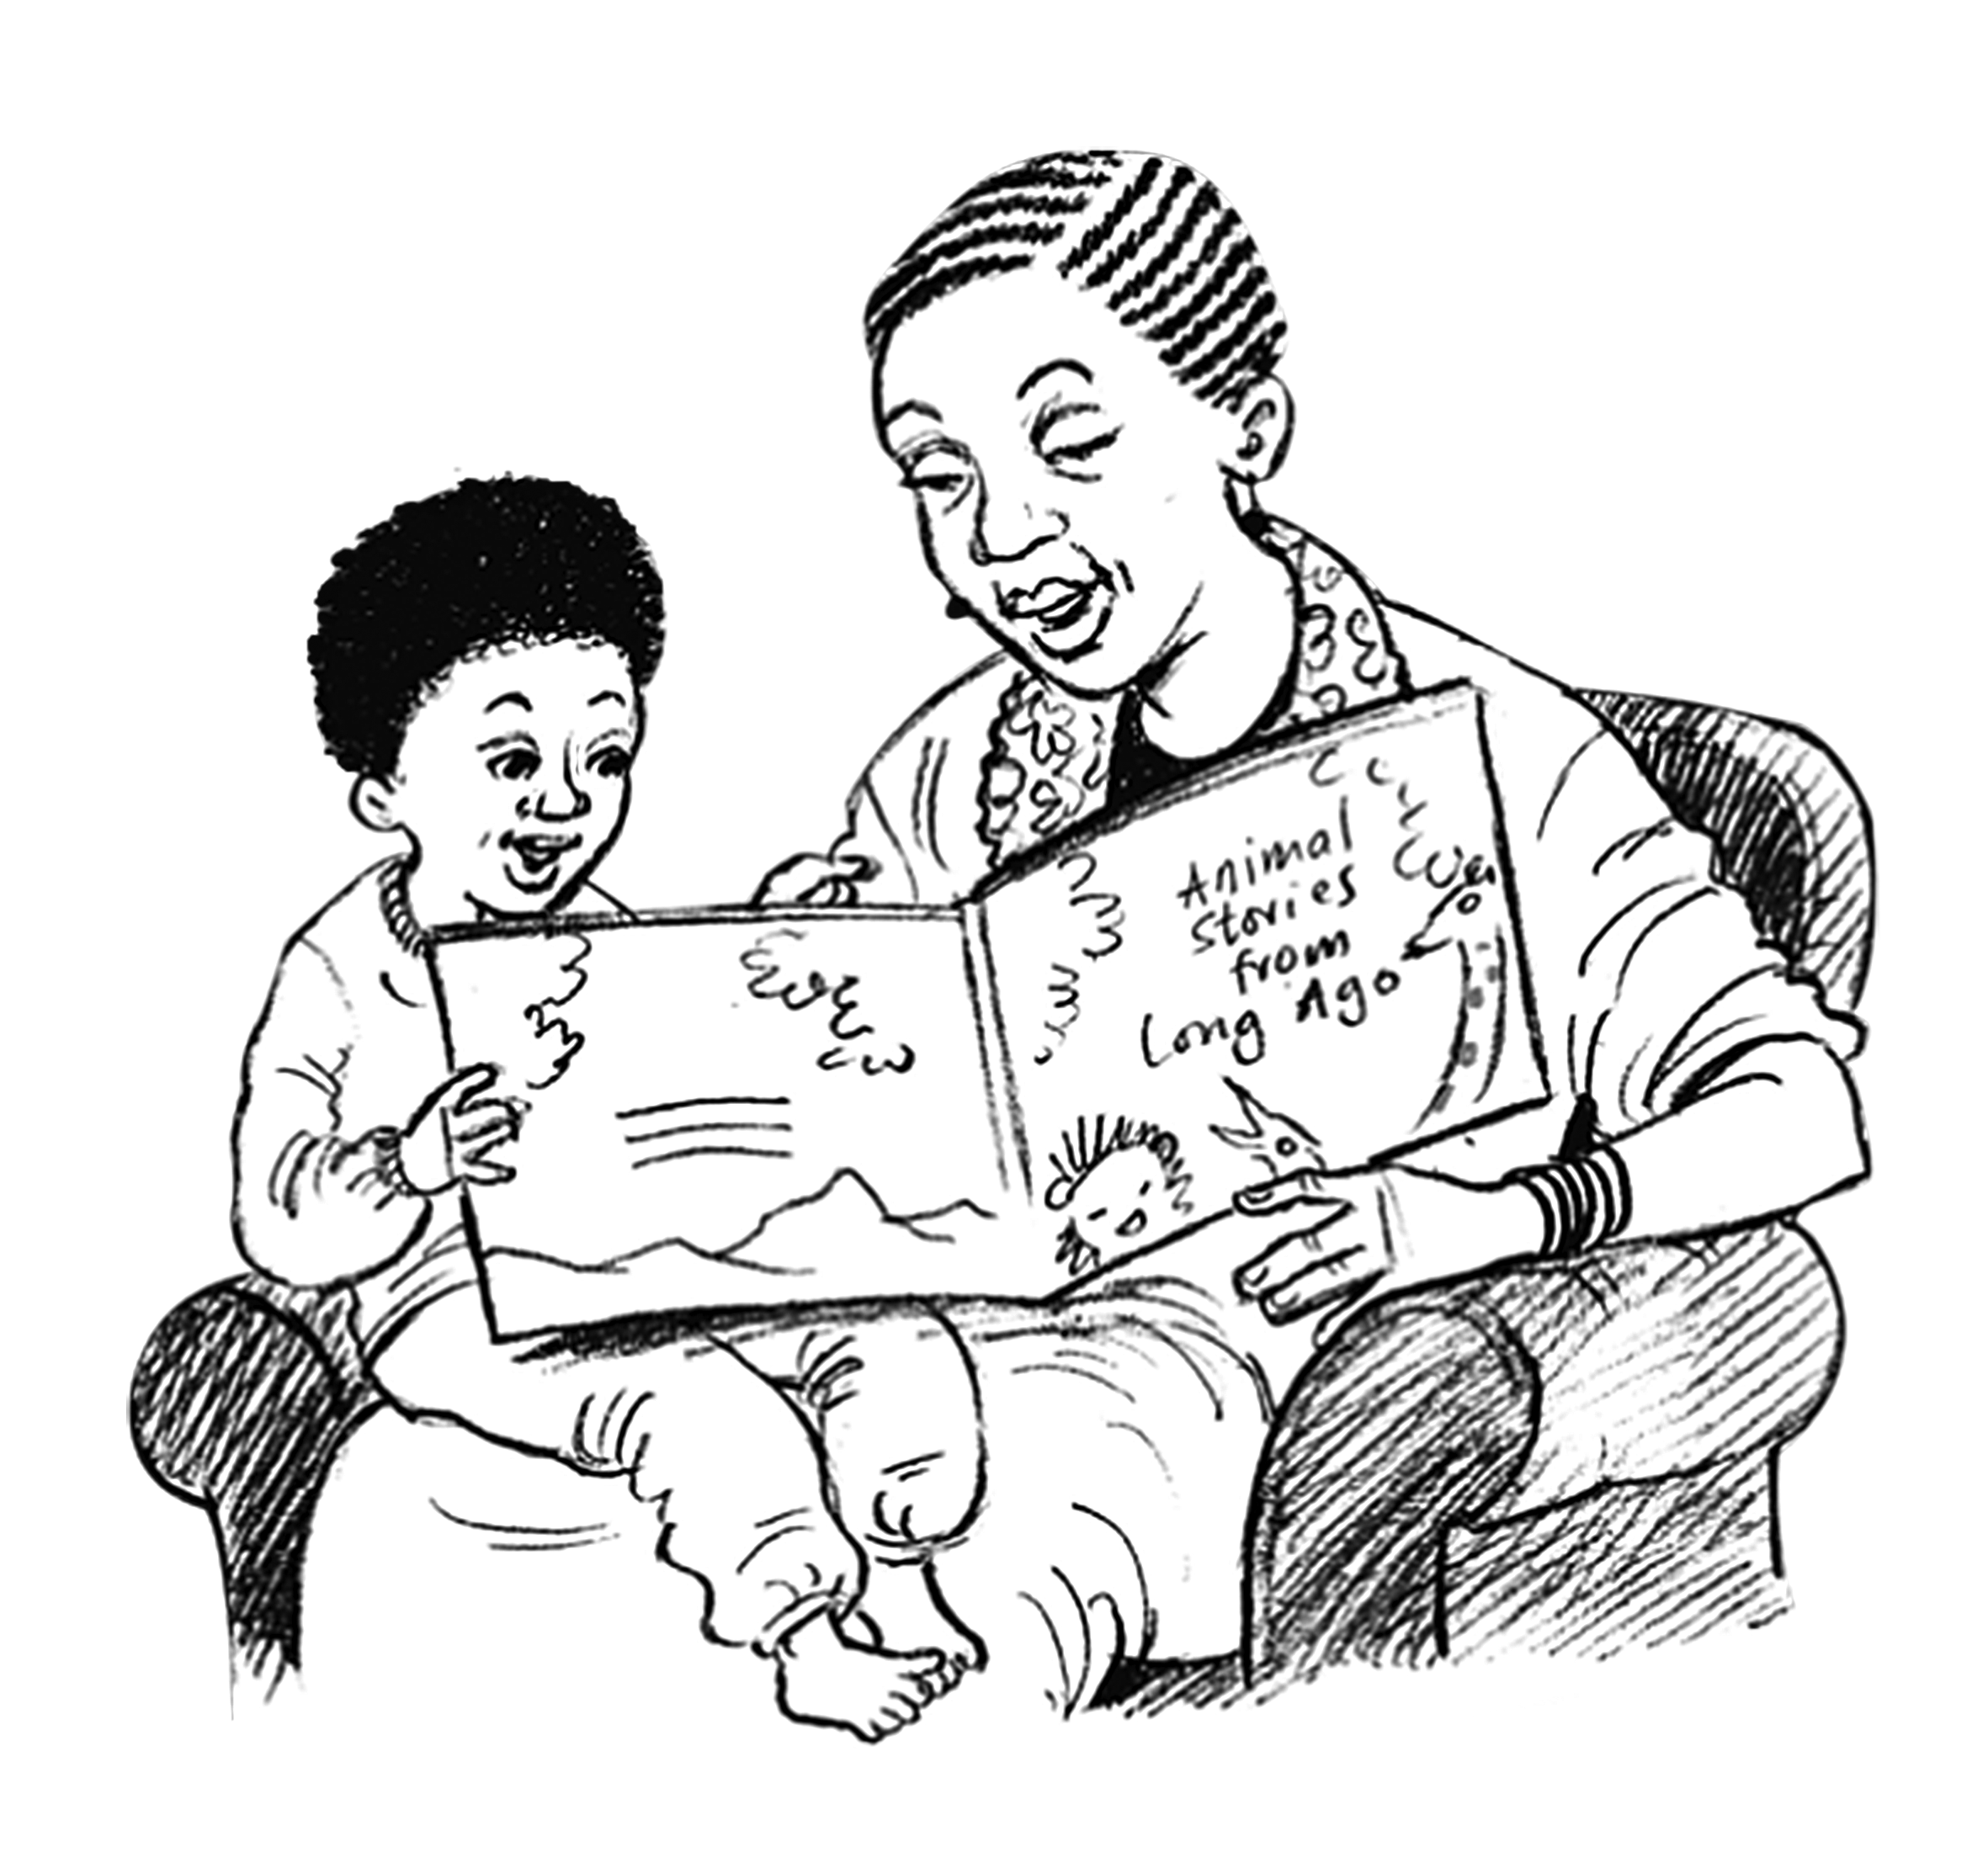

Course Facilitator Date

