Esi sisiqinisekiso sokuba u

Uyigqibile iNkqubo yaBazali yoku
xhasa imfundo yabantwana abancinane ekhaya

Izihloko zezifundo zezi:
Abazali/abalondolozi njengootitshala bokuqala bomntwana
Inkqubo yokubhala kunye nokubaluleka kokuzoba
Ukubaluleka kokubalisa nokufunda amabali
Ukuzenzela incwadi ngokwakho
Imidlalo yokumamela yokunceda ngokufunda nokubhala
Imiba esisiseko yokufunda kunye nokuphuhliswa kwezibalo
Imidlalo yokuphuhlisa imisipha emikhulu nemincinane
Ubuzali obakhayo

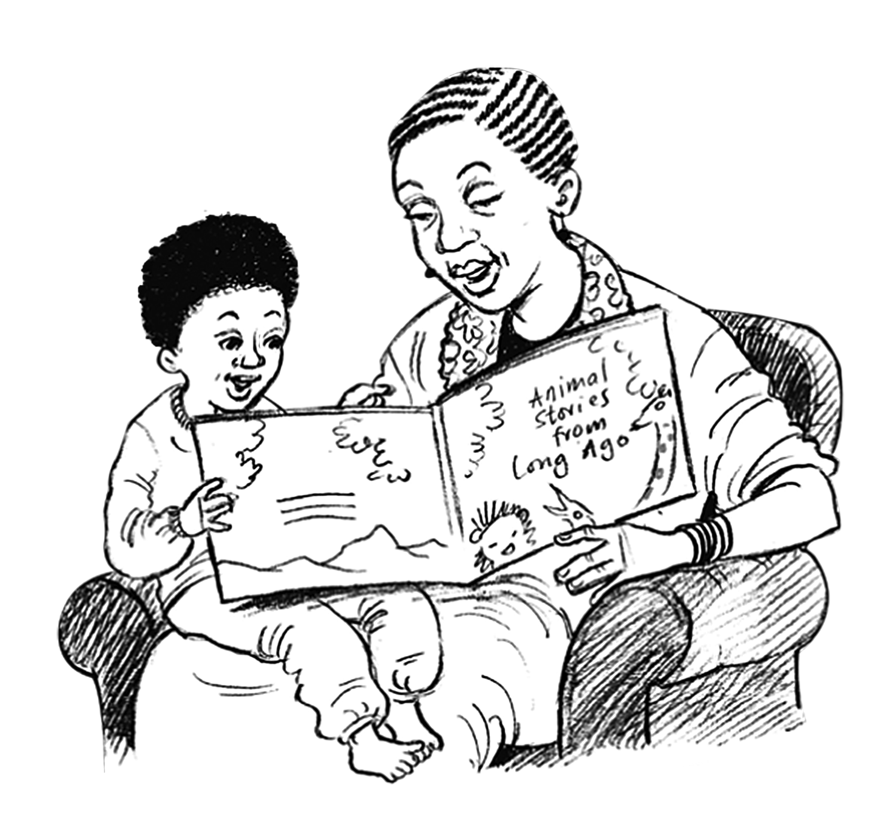

Umphembeleli wezifundo Usuku

