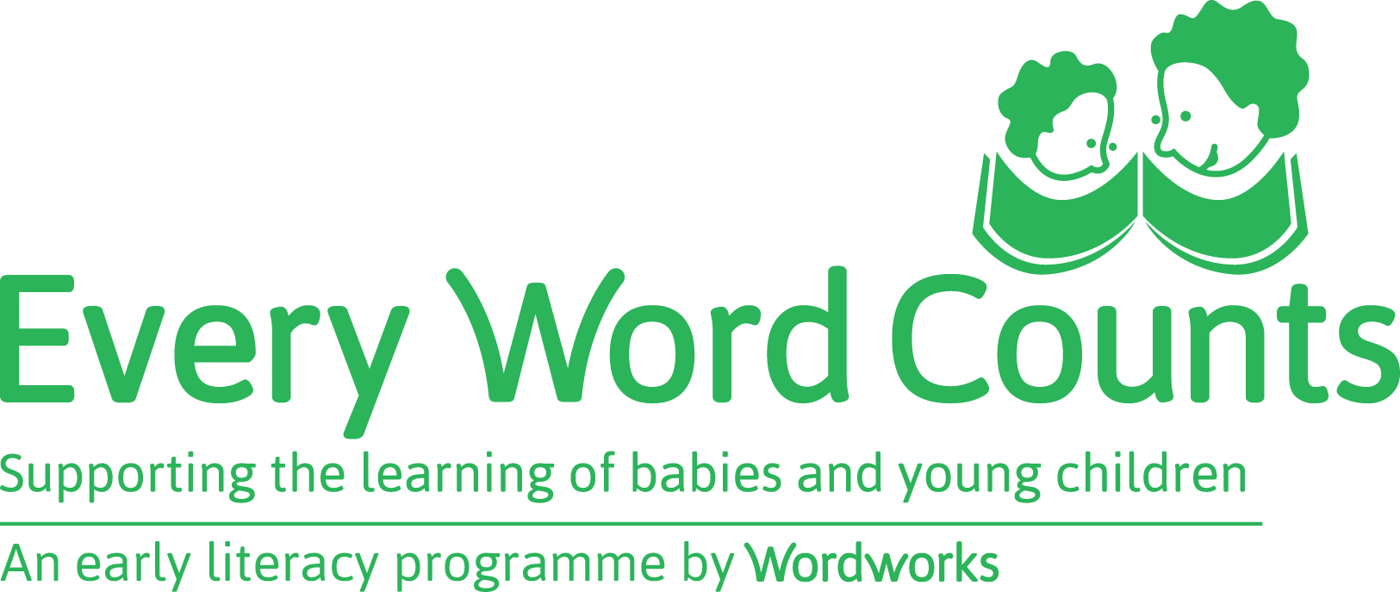
REQUEST FOR PARENT RESOURCES: SESSIONS 1 – 6
The following will be delivered for each parent:
- Parent workbook
- animal cards
- Storybook
- stationery pack (a blank drawing book, crayons, scissors, glue and a folder)
Choose 1 of these 2 ways to complete your request for resources:
- Type into this form and email it to admin@wordworks.org.za
- Write on this form and fax it to 086 775 7930

YOU MUST SUBMIT YOUR REQUEST FORM AT LEAST TWO WEEKS BEFORE THE START OF YOUR SESSIONS WITH PARENTS
Please complete ONLY ONE form per school/centre

NAME OF SCHOOL/CENTRE/ORGANIZATION

__________________________________________
Dear Wordworks,
Please send us resources as follows:
PARENT TOTALS FOR  SESSIONS 1 – 6 RESOURCES | INSERT TOTALS
ENGLISH
AFRIKAANS
ISIXHOSA
TOTAL NUMBER OF PARENTS

Thank you! ☺
EWC Parent workshops Lead Facilitator: __________________________

Remember to distribute workbooks at Session 1, stationery packs & animal cards at Session 3, storybook at session 5

