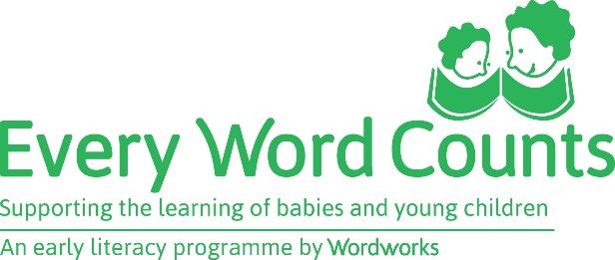

Getting feedback from parents
Feedback is a very important part of facilitating, and a useful tool. It can show facilitators whether they are on the right track in terms of getting their messages across to parents and changing their thinking, and whether they are pitching the activities at the right level. It can also make facilitators aware of small but important issues or burning questions that parents may have, so that they can address these (either privately or in the big group) before they become bigger problems. Above all, it can show facilitators whether the parents are seeing this as a positive experience and want to continue attending.

After Session 3
This feedback after session 3 is very open ended. It can be written on plain paper and can take the form of an informal letter to the facilitators, or a card. Facilitators can say something like "Write to us, your facilitators, and tell us how you are finding the programme. Are you enjoying it? Is there anything that you are doing at home now that you didn’t do before? Have your children noticed anything different about the way you do things at home? "

Parents do not have to put their name on the letter, but obviously they can if they wish to. Half a page is enough, but some parents will want to write more.
The other thing to say about these letters is that often the facilitators can get some lovely quotes out of them for their portfolios and their Programme reports. Also, they are great to use as part of the display at the graduation.

Session 6:
As part of session 6 or just before the graduation, parents are asked to give feedback about the programme. They use the feedback form which facilitators must print. Parents must be given a quiet space and enough time during the session to complete this form. The questions on the form will guide them, but they should be encouraged to look back and really think before they write: how has the programme influenced their attitude and their parenting? Are they different now from what they were before they started this programme? No names are required on the form unless parents wish to.

