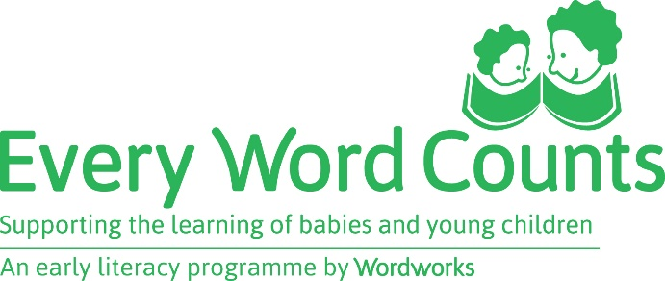

Amazwi akhuthazayo esingawathetha ebantwaneni
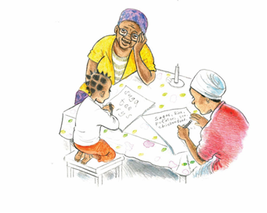
Ndixelele ngemini yakho.
Kulungile!
Usendleleni elungileyo ngoku
Ulungile kakhulu kuloo nto
Ufunda ngokukhawuleza
Kuza kakuhle
Kungcono kakhulu
Mhle lo msebenzi
Wenza umsebenzi oncomekayo
Ndiyazingca ngendlela osebenze ngayo namhlanje
Ndiyavuya ukubona usebenza ngale ndlela

Kuyonwabisa ukwenza izinto nawe
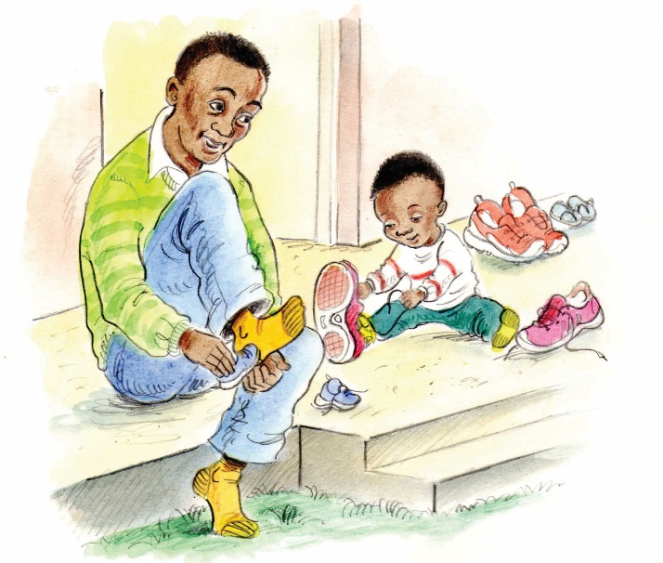
Uyifumene / useza kuyifumana
Ndiyakholelwa kuwe
Usebenza ngokuzimisela
Yiyo leyo!
Izimvo zakho zinika umdla
Bendisazi ukuba uyakwazi
Wenze ngcono kakhulu
Qhubeleka nomsebenzi omhle

Positiewe dinge om vir kinders te sê
Vertel my van jou dag
Mooi so!
Jy is nou op die regte pad
Jy is baie goed daarmee
Jy leer vinning
Jy vorder goed
Dis baie beter
Goeie werk
Jy doen dit baie goed
Ek is trots op jou werk van vandag
Dit maak my bly om jou so te sien werk
Dis lekker om dinge saam met jou te doen
Jy’s amper daar!
Ek glo jou
Dis die beste wat jy nog gedoen het!
Jy het dit!
Jou idees is interessant
Ek het geweet jy kan dit doen
Jy het mooi verbeter
Hou so aan
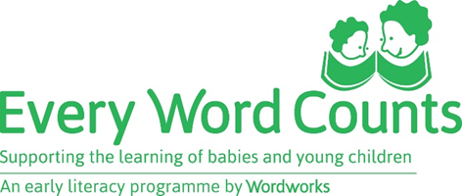

Umyalezo okhuthaza izingane
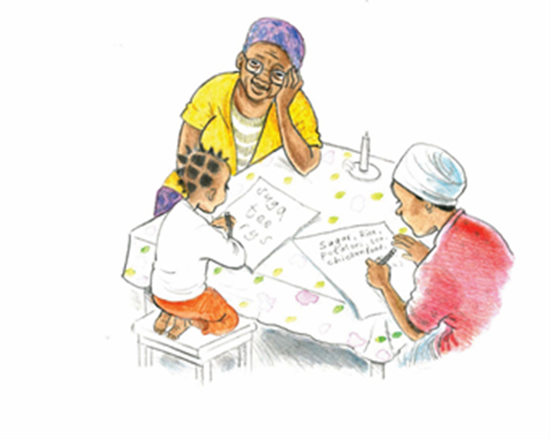
Nazo ke!
Uyibambe kahle impela manje.

Wenza kahle.

Ufunda ngokushesha.

Lokho kuza kahle kakhulu.

Thatha isikhathi sakho.

Uqhuba kahle.

Wenza kahle.

Ungenza ngiziqhenye.

Ngiyajabula ukubona okwenzayo.

Kuyajabulisa ukwenza izinto nawe.

Uzamile.

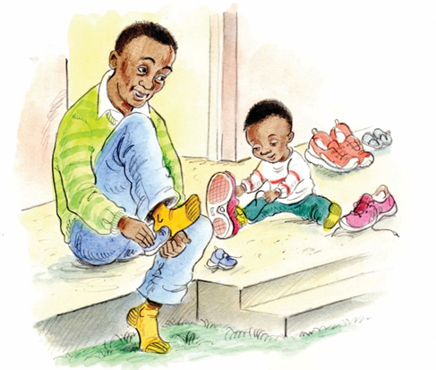
Ngiyakholelwa kuwe.

Ungawushintsha umqondo.

Nazo ke!

Ngiyawuthanda umubono wakho.

Ngazile ukuthi uzoyenza.

Ungazama futhi nakusasa.

Qhubeka uzame, uyafunda.

Positive things to say to children
Tell me about your day
That's right!
You're on the right track now
You are very good at that
You are learning fast
That's coming on nicely
That's much better
Good work
You're doing a good job
I'm proud of the way you worked today
I'm happy to see you working like that

It's fun to do things with you
You've just about got it
I believe you
That's the best you've done!
That's it!
Your ideas are interesting
I knew you could do it
That's quite an improvement
Keep up the good work

