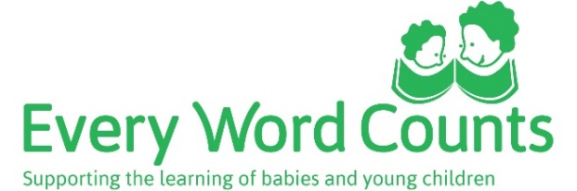

Learning language through play
What new words can children learn from water play? | How can adults support water play?
What new words can children learn from making puzzles? | How can adults support making puzzles?
Notes: Pretend play

Notes: Card games

Notes: Listening games

