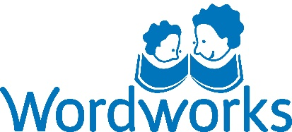
Partner’s logo

This is to certify that

has attended the

Every Word Counts

training for ECD practitioners/home visitors/parent-group facilitators, and has promoted babies and young children’s language development and early literacy

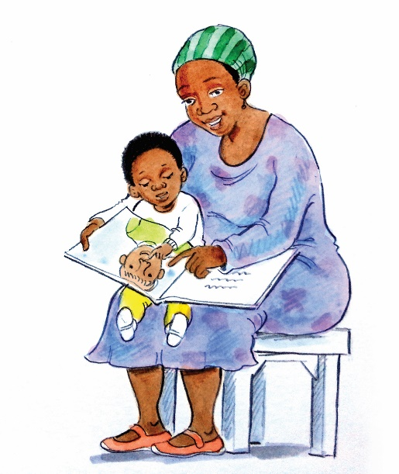

_______________________ ____________________
(Partner’s Director) Date

